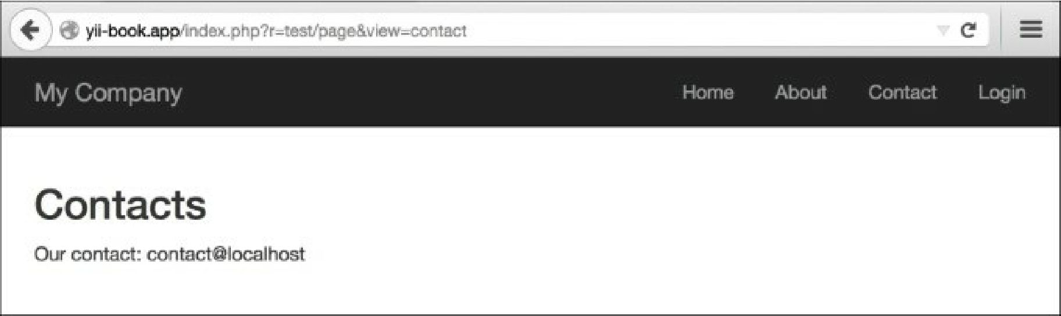

5. Alternatively, you can type in the URL http: //yii-book. app/test/page/view/about, if you have configured clean URLs with a path format.

How it works...

We connect the external action named \yii\web\viewAction, which simply tries to find a view named the same as the $_get parameter supplied. If it is there, it displays it. If not, then it will give you a 404 not found page. In case viewParam is not set, the defaultview value will be used.

There’s more.

**About ViewAction**

There are some useful \yii\web\ViewAction parameters we can use. These are listed in the following table:

|  |  |
| --- | --- |
| Parameter  name | Description |
| defaultView | The name of the default view when the yii\web\ViewAction : : $viewParam GET parameter is not provided by the user. Defaults to ' index'. This should be in the format of path/to/view, similar to that given in the get parameter. |
| layout | The name of the layout to be applied to the requested view. This will be assigned to yii\base\Controller: :$layout before the view is rendered. Defaults to null, meaning the controller’s layout will be used. If false, no layout will be applied. |
| viewParam | The name of the get parameter that contains the requested view name. |